Name: Charles Shin

Date: 5/8/2021

Course: IT FDN 110 A Sp21: Foundations of Programming: Python

Assignment05

GitHub URL: <https://github.com/shin900215/IntroToProg-Python>

# Assignment 05: ToDoList using Dictionary and Utilizing GitHub

## Introduction

This assignment is to familiarize with adding/removing data using List or Dictionary. The Dictionary was used in this assignment. Also, how to communicate with others using the community called GitHub is shown in this assignment.

## Script Construction

Figure 1 shows the header of the script, and it shows who and when the latest change was made.

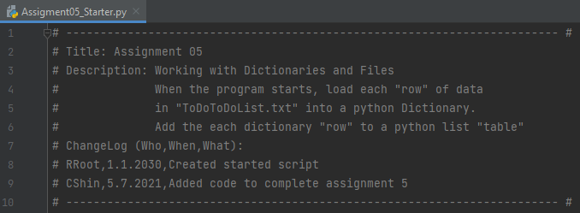

Figure 1. Header of the Assignment

Once the header was created, I moved to Step 1. Figure 2 shows the processing of the script. As shown in the figure, a simple command opens the string data. However, it is not printed/shown to the user.



Figure 2. Processing of the Assignment

No modification was made on Step 2, as it is regarding the Menu and already predefined. Figure 3 shows Step 3 of the script. It opens the string data file (ToDoList.txt) and uses its values to construct a dictionary. The text file is not included in the .zip file that will be submitted, but figure 4 shows the file and its structure.

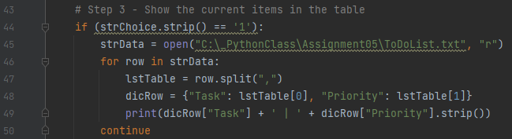

Figure 3. Step 3 of the script

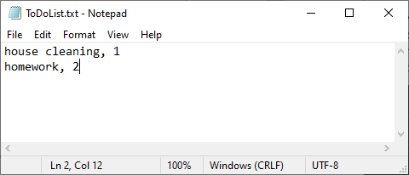

Figure 4. Original ‘ToDoList.txt’ File

Figure 5 shows a script for Step 4. As shown, the script asks the user to input the task and the priority. Using these values, the script constructs a row of dictionary that is composed of “Task” and “Priority”.

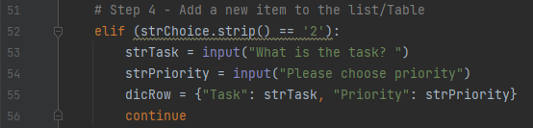

Figure 5. Step 4 of the Script

From Step 4, the dicRow was constructed using the user’s inputs. To remove those input values, which is Step 5, empty values for dicRow was commanded to delete the prior input. Figure 6 shows an actual script for it.

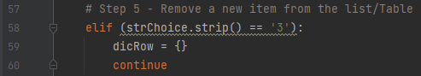

Figure 6. Step 5 of the Script

Step 6 is a script for saving user input to the datafile (i.e. ToDoList.txt). Figure 7 shows the sequence of the script. It first opens the text file, writes the user inputs separated by comma, and closes the text file. Note that “a” for append was used in order to retain the prior data.

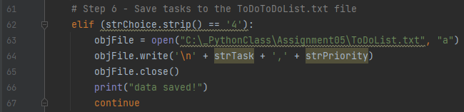

Figure 7. Step 6 of the Script

Step 7 is to exit the program. Nothing much had to be done, so a simple “Good Bye!” print was added.

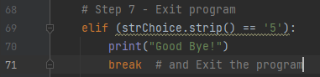

Figure 8. Step 7 of the Script

## Results

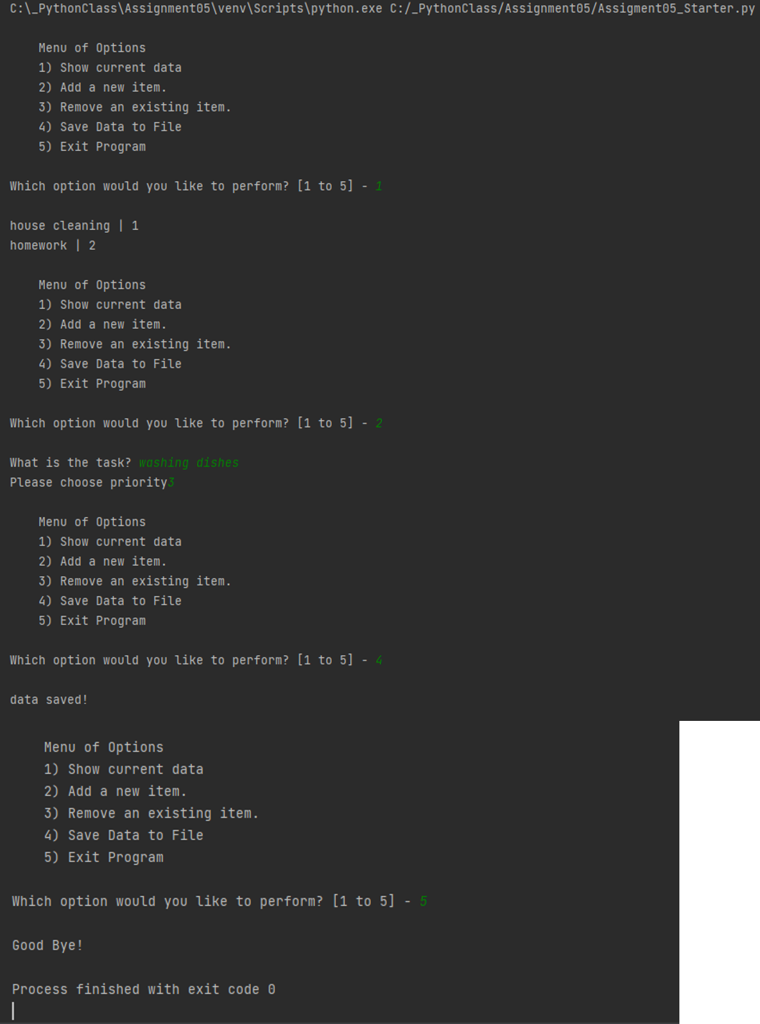

Figure 9. Running the Script using PyCharm

Figure 9 shows running the script in PyCharm environment. It starts with asking the user to select an option, and I ran the whole script by selecting the menu from 1 to 5. Note Menu 3 was intentionally skipped to see the text file successfully saves the user input.

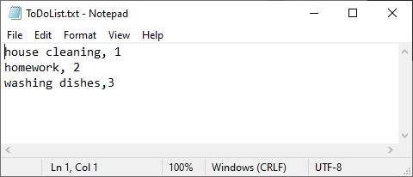

Figure 10. Saved Result of the Text File after Menu Selection #4 in Figure 9.

Once the script was run by PyCharm, the text file was opened to check if the user input was saved successfully. Figure 10 shows the result of the saved file.

Figure 11 shows the result of the script run by the OS. Again, Menu selection 4 was not selected to see the result of successfully saved data file. Also, at the end of the figure, Menu selection #5 was about to be selected but not yet selected, as that selection would automatically close the window.

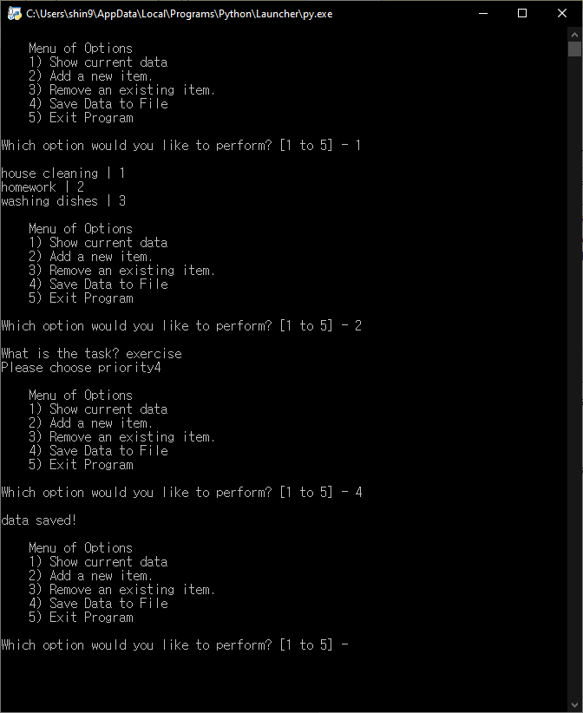

Figure 11. Figure 9. Running the Script using the OS

Once the script was run by the OS, the text file was opened to check if the user input was saved successfully. Figure 12 shows the result of the saved file. Note that the text file now contains four items: 2 original items, 1 added item from running by PyCharm, and the last one added by running by the OS.

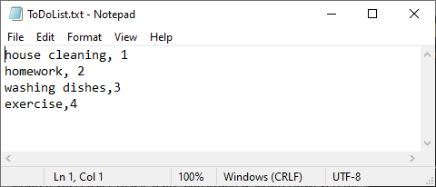

Figure 12. Saved Result of the Text File after Running the Script for the Second Time

## Summary

In this assignment, how to load/add/delete the data from (or to) the text file was learned. Also, this assignment will be submitted to both GitHub and the UW Canvas. Submitting it to GitHub will get me acquainted with the GitHub community. This assignment was the first time using the pre-constructed script. It was easier to use a pre-constructed script. However, for some lines, it took some time to understand what the original creator’s intention was.